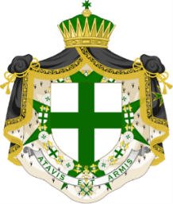

The Military and Hospitaller Order of Saint Lazarus of Jerusalem

Grand Master: His Excellency, Don Francisco de Borbón Graf von Hardenberg GCLJ

The Grand Priory of England and Wales
Grand Prior: The Most Honourable the Marquis of Lothian PC, GCLJ, KC, DL
Bailiff: H.E. the Chevalier Charles Holloway GCLJ, KMLJ

August 2023

NATIONAL SERVICE OF INVESTITURE, LONDON – Saturday 21 October, 2023

The Grand Priory of England and Wales invites Postulants, Members of the Order and their guests to this event, the programme for which appears below.
The Investiture Service will take place in St Paul’s Church, 32A Wilton Place, London, SW1X 8SH, followed by a reception and lunch at The Cavalry & Guards Club, 127 Piccadilly, London, W1J 7PX.

Saturday 21 October
9.30am Deputy Marshals report to the Marshal in church
9.45am Other Ceremonial Officers report to the Marshal
10.00am Postulants, promotees and those receiving awards report to the Marshal
10.30am Members assemble and robe quietly before taking their seats in the nave
11.00am Service of Investiture
Investing Officer: The Grand Prior - The Most Honourable the Marquis of Lothian PC, GCLJ, KC, DL
In the presence of the Grand Master Emeritus - The Most Excellent the Duke of Seville GCLJ
Preacher: The Revd Canon Jeremy Haselock GCLJ
1.00pm Pre-prandial drinks (Cavalry & Guards Club)
1.30pm Lunch in The Coffee Room

Members and guests are asked to be seated in the nave by 10.45am. Postulants, promotees and those receiving awards should take their places in the reserved seats, as directed by the stewards.

DRESS:

Mantles of the Order, neck decorations and full size insignia. Gentlemen are requested to wear the Uniform of the Order/Morning Dress/Military Uniform/Highland Dress or a Dark Lounge suit with the tie of the Order. Cordons to be worn only with uniforms or Highland Dress. Breast stars must not be worn on lounge suits; one breast star only on Morning Dress.
Ladies should wear dark formal dress of three-quarter length or longer, with sleeves. Mantilla and black gloves may also be worn. Ladies accompanying gentlemen in uniform may wear cordons if their rank entitles them to do so, as may any lady of appropriate rank who is also a Commander of a Commandery.

A collection will be taken during the service for St Paul’s, Knightsbridge.
An envelope collection will take place during lunch in support of the St Lazarus Charitable Trust.

Please send your booking form, with a cheque for £115 per person if attending the Investiture Luncheon, to:
Dame Val Hiscock DCLJ, 14 Lawford Place, Lawford, Manningtree CO11 2PT or by email to val@lawfordpark.co.uk (if making online payment)
Cheques should be made payable to ORDER OF ST LAZARUS or MHOSLJ, and replies must be received as soon as possible.
Please note that numbers are limited to one hundred & twenty (120) for lunch. Priority will be given to those being admitted, promoted or receiving awards. It may not be possible for all those who wish to attend to bring a guest, but every effort will be made to accommodate them.

Cancellations may be made without penalty up to Friday 24th September, after which date no refund will be given.

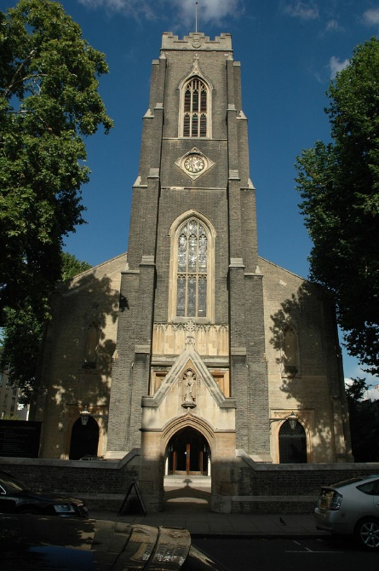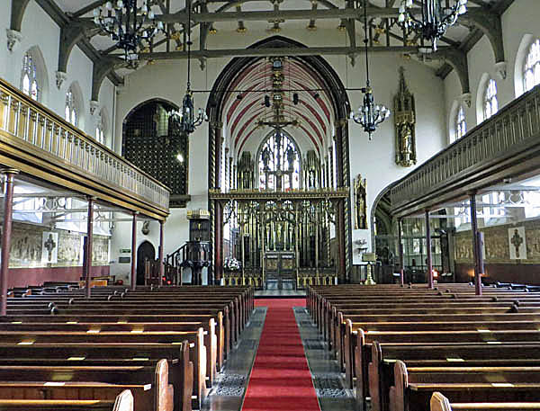

St Paul’s Church, Knightsbridge

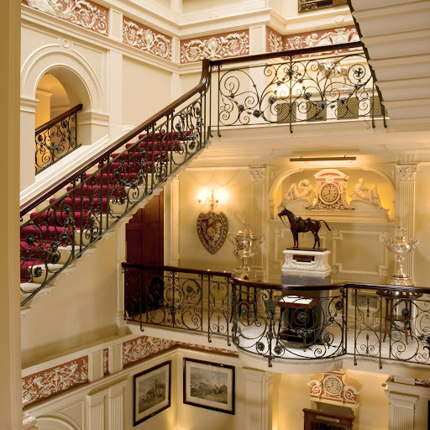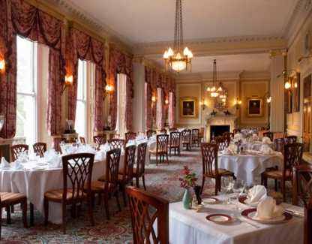

The Cavalry & Guards Club, Piccadilly

